MHS Home and School Meeting Minutes
October 10th, 2024 7pm Library

Attendees: Sophia Pham, Lori McTamney, Sandy Katz, Susan Demedio, Katie Shireman, and Deanna Roeger
MHS Staff Reports:
Principal- Katie Shireman reported on behalf of Dr. Euker.
No school on Monday: Simon’s heart is in the gym. This is an opportunity for teens to get a free heart check. See newsletter for more info
National Honor Society Induction occurred this week, it was beautifully done.
We practiced all three security drills last month and it was very successful.
Homecoming/Color Wars/Pep Rally was a fun filled day centered on students having fun with their classmates.
This year the HS staff is focusing on becoming proficient with LinkIt. Teachers have been attending in-house training delivered by Jason, Pfiel, the instructional coach at the HS. LinkIt is a data platform that houses all assessment data for the district. Teachers want to start using this system for their unit tests rather than scan trons.
Senior cap and gown information went out this week and is due 10/21. We are waiting on baby pictures for some seniors.
Halloween is coming up and it is a fun time for HS. Each department will dress up in a different theme and there will be a friendly competition. The admin team will be super heroes!! I am Cat Woman.
It has been a great start to the year and I look forward to the rest of the fall.
Teachers Report- Andrea Borgmann forwarded the below.

METHACTON H.S. NEWS FOR HOME AND SCHOOL

AREA | NEWS
NURSES OFFICE   | - Monday, October 14th MHS is hosting Simon's Heart for free cardiac screening for youth ages 14-25 during our Inservice day  - Monday, October 21st MHS is hosting Skippack Pharmacy for a Community Flu/COVID vaccination clinic 3pm-7:30pm  - Tuesday, October 29th MHS is hosting American Red Cross for a Community Blood Drive 2:30pm-8pm
THEATER | Theatre Company members are doing. We are well underway with our rehearsals for our fall play, A Christmas Carol. Performances are November 14/15/16, all at 7pm. We have 70 K-12th graders in the cast and will have around 20 crew members!  Our WPG students would also like to thank our faculty and staff for their support during our Staff Jeans Day for Suicide Prevention Awareness, where we raised $182!
SENIOR  NEWS   | 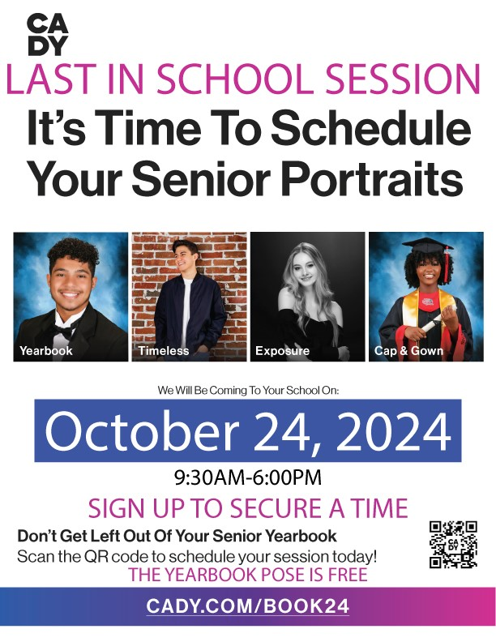  DIRECTIONS FOR SCHEDULING:  https://drive.google.com/file/d/1PPht5cQcRiAQw1eXwfCtG7cUO3Hg-8M9/view?usp=sharing
GIRL’S  VOLLEYBALL | 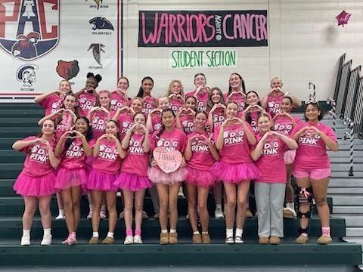  Girls' Volleyball Dig Pink Fundraiser Success!  While Methacton Girls' Volleyball lost 3-0 to PJP during their annual Dig Pink Game on Thursday 10/3, the team raised over $4,000 for the Side Out Foundation. We thank everyone for their yearly support of this amazing event!  Methacton now stands with a 10-6 overall record and a PAC record of 6-5. Their next match is at Perkiomen Valley on Tuesday 10/8. Go Warriors!
CHEER TEAM   | 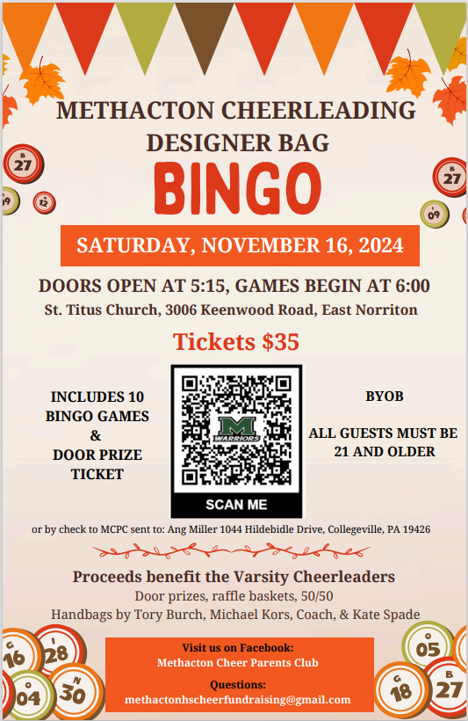
VARSITY  FOOTBALL | 
MARCHING  BAND   | Marching Band Wins 1st Place  Methacton Marching Band placed 1st at both their competitions on 9/14 at Spring-Ford AND on 9/21 at Phoenixville. Their next competition is on 10/12 at Exeter High School.
Counseling- No Report
H&S Reports: Sandy Katz reported the below.
President-Susan Demedio had Katie Shireman review the 4 mini grants we received. Susan made a motion to pass on Tara Florentino’s cart of diverse Spanish games for $482.84 and to pass with a partial contribution of $250 to Bob Helm’s science fair club and $250 to Alexa Washington’s BSU club for trip support to benefit the students. Mary Fitzgerald’s theater request for privacy screens and make up carts denied at this point due to lack of funds and amount of requests. Can relook in the Spring. Deanna seconded it and the rest approved.
Vice President- Katie Shireman reviewed in detail the four mini grants.
Treasurer-Sophia Pham said with $8,472 income of no frills and the $268 from dessert venmo, that our budget increased to $9975, enough to cover this year’s budget. Susan Demedio purchased the extra desserts and did not expense so we could save the venmo money to use for souper luncheon needs. No expenses in September and $6171.07 in income from no frills.
Recording Secretary-Deanna Roeger shared that if there was no one stepping up for treasurer next year that Hemisha Ly said she could do it. She would only be able to for a year since her kids will both have graduated by then. Also reminded that Chrissy Charles still doesn’t get Bill Clarks Warrior News and I have to forward them daily to her to post on FB.
Corresponding Secretary- No report

District Reports:
Special Education Alliance Home and School-
  - Thank you to everyone who came out for our first Home & School meeting of the year. It was great seeing so many new faces, as well as the many that we recognize as long-time members. If anyone is interested in volunteering for our committees please reach out to SEAMethacton@gmail.com, if you have not already signed up. A special thank you as well to Dr. Gravinese, who explained many of the changes taking place within special education this year in our district. The opportunity to hold open and casual conversations around topics like these are truly appreciated. 2. We’re pleased to announce the return of the SEA Fall Fest! The House of Wiggle Goats will be hosting our event on October 12th from 2:00pm-4:00pm. We’ll be holding lots of fun and inclusive activities, and the Cuddle Corral will be open! This is a paid event. Please see the attached flyer for details and registration. Must Pre-Register 3. Chick Fil-A Audubon is hosting a Community Cares event for the Special Education Alliance Home & School on October 15th. Just let them know you’re there to support the Methacton SEA Home & School when you order! 4. Our kickoff presentation for the 2024-25 school year will be given by Kris Koberlein of the MCIU on the topic of Post Secondary Transition. This process begins at age 14, but learning about what it entails before it begins can be highly beneficial. Kris works closely with Methacton School District regarding transition and is able to give us unique insight into how we can work together to prepare our students for life after MHS. 5. Save the date for November’s presentation by Dr. Steve Stunder from Chestnut Hill College, on College Access for Neurodiverse Students, November 21 at 7:00pm. 6. Save the date for our annual Kendra Scott fundraiser to be held the weekend of December 13-15! Stay tuned for a flyer and details! 7. Check out SEAofMCC on Facebook to find out more about the following: a. The Montgomery County Resource Expo October 8th from 6-8pm, at the MCIU (2 W. Lafayette St., Norristown, PA) b. Parenting Special Needs Magazine’s latest edition, including their latest College and Employment Supplement, Transition Planning Tips and more! c. The Arc Alliance & the Include Me team online parent info sessions on Transition d. TOPSoccer KOP recreational team registration is still open. Session extends through October 19th. 8. Our next SEA H&S meeting will be on November 20th at 7:00 in the MHS Library. Dr. Dani Fowlston will be presenting on Skyview and Arcola special education staffing & resources.

Post Prom- Katie Shireman shared that the first post prom meeting was last Tuesday and only 6 decorating spots left to fill. She also said the paint your spot faired well, Will partner up with local business (Sherman Williams, Home Depot, and Lowes) for paint/supplies discount. Will be proactive of asking seniors in May when picking up their stickers to fill in a form regarding if they plan to paint or not. Lori McTamney thought it went well and everyone had fun and she learned a lot doing it herself.
School Board- In discussion of new MHS construction but a lot of disgruntlement over the costs.
MCC- No Report

Dates to Remember:
October
14- No School
21- Seniors Cap and Gown orders due in
November
1st- No School/Marking period Ends
4th/5th-NO SCHOOL
7th- H&S Meeting at 9:15am
14th- SOUPER LUNCHEON

